
A


15528 St. Rt. 3 N ● Loudonville ● 419-994-1611
David J. Koehler, Pastor

March 18, 2015
www.loudonvillebaptist.org

Opportunities to grow…

Ladies Bible Study – Fridays – 9:30am
All ladies are welcome and are encouraged to attend. Current Study: “Stretch My Faith, Lord” It is based on the book of James. We hope you will be able to join us in this study. If you have any questions please see Sharon Sigler.

Sunday school fellowships – Sunday Morning @ 9:45am
If you are not active in one of our Sunday school fellowships we invite you to join us. These are small group meetings intended to help you dig into the Bible deeper and develop relationships with others who desire to grow in the Word.

Opportunities to go…

Men’s Bible Study – Saturdays @ 9:00am

Sowing the Seed Follow-up/Visitation - Saturdays @ 10:00am
We need your help in visiting new people in the church and following up with recent Sowing the Seed mailings. This is another important way you can ‘go’, please join us!

GriefShare – Mondays @ 7:00pm

Missions Conference March 18th-22nd, 2015
We will have services Wednesday-Friday at 7pm. Saturday will be a free day. Then Sunday, we will have our regular services in addition to our International Lunch. This is an opportunity for each family to bring an ethnic dish, or maybe a family favorite. There are sign up sheets
in the foyer. We will have more details on the meal upcoming. Teens-Adult will meet in the auditorium for Sunday school. Each of the children’s classes will have a missionary visit.

NURSERY
WORKERS
“We shall not all sleep, but we shall all be changed…”
I Cor. 15:51b

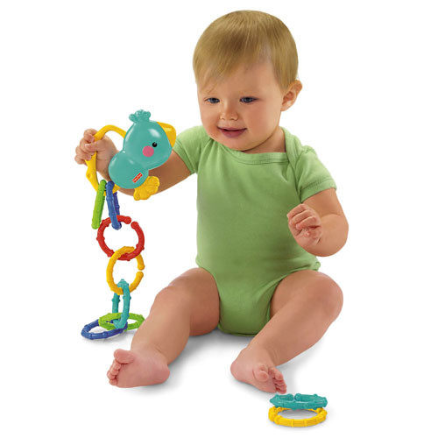

Please remember to find a replacement if you are unable to be in the nursery.

Tonight: Two Volunteers
Sunday School 9:45am: Chris Koehler & Volunteer
Sunday Worship 11am: Jane & Sarah Mickle
Sunday Evening 6pm: Karen Coffman & Volunteer

March Birthdays

March 20 Karen Coffman
March 20 Jennifer Alexander
March 21 Rick Myers
March 22 Ruth Mickle
March 29 Jacob Koehler
March 30 Julie Rawlins



Active Deacons:
Skip Cook; Terry Meek; Ron Rodriguez;
Steve Schultz; Steve Seaman



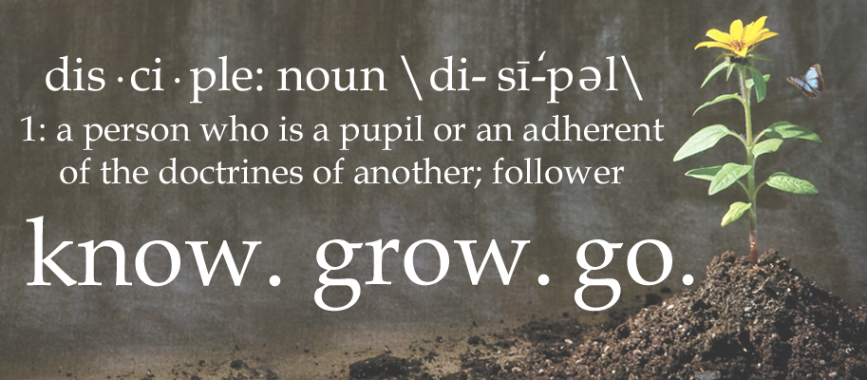

“Discipleship” Luke 14:27 know. grow. go.
“And whosoever doth not bear his cross, and come after me, cannot be my disciple.”

WEEKLY SERVICE TIMES
Sunday School 9:45am
Sunday Morning Service 11:00 am
Sunday Night Bible Study 5:00 pm
Sunday Evening Service 6:00 pm
Wednesday Evening Service 7:00 pm
PRAYER LIST
Ongoing Health Concerns
Gary Mickle – recovering from neck surgery
Nancy Pullin - pending back surgery – April 2
Arnie Hammer –pray for his healing
Sharon Sigler – foot to heal
Geraldine Clyburn
Holley Cook
Phyllis Simpson

Colonial Manor Nursing Home
Helen Bowman – Room 35

Salvation
Don Seaman (brother of Bob Seaman)
Unsaved husbands of church members
John Dembowiak – Friend of the Koehler’s

College Students
Ruth Mickle – Massillon Baptist College (Massillon, Oh)
Chrissy Rawlins – OSU (Columbus Campus)

Our Country

President Barack Obama
Our Government officials
Our military, the war

Military Personnel
Matt McDonald – Navy
(Kim Schaffer’s son)
Ben Coffman – Army
(Bob & Karen Coffman’s son)

Cancer
Vicki Schag – stage 1 cancer on eyelid
(Neighbor of the Koehler’s)
Tonya – (Trish Ganfield’s mother)
John Perry – (Trish Ganfield’s uncle)
Bobbie Wickham – (Trish Ganfield’s aunt)
Dr. Earl Jessup – will be moving to AK. – more tumors
Amy Veldman

Other Needs
The Coffman’s Life Stone Ministry:
Ashland Cty Jail Church Services every Sunday morning. Women’s Jail Ministry Bible Study – Wed’s @ 9:00am
Wisdom for Pastor
Sunday School Ministry
Teen and youth - Soldiers for Christ

PRAYER REQUESTS/SERMON NOTES
__________________________________________________________________________________________________________________________________________________________________________________________________________________________________________________________________________________________________________________________________________________________________________________________________________________________________________________________________________________________________________________________________________________________________________________________________________________________________________________________________________________________________________________________________________________________________________________________________________________________________________________________________________________________________________________________________________________________________________________________________________________________________________________________________________________________________________________________________________________________________________________________________________________________________________________________________________________________________________________________________________________________________________________________________________________________________________________________________________________________________________________________________________________________________________________________________________________________________________________________________________________________________________________________________________________________________________________________________________________________________________________________________________________________________________________________

